PROJECT REPORT

Project Title : Cafeteria Menu Display

INTRODUCTION

Project Overview
The Cafeteria Menu Display System is a digital solution designed to replace traditional paper menus with a dynamic, real-time display. It allows cafeterias to showcase food items with prices, descriptions, and dietary icons in a clean, readable format on a screen. The system aims to reduce printing costs, save staff time, and improve the overall customer experience by ensuring menu information is always accurate and up-to-date.
The project consists of two main interfaces: a public customer display and a secure admin panel. Staff can easily log in to add new items, update prices, upload images, and mark items as available or sold out. Changes made in the admin panel are instantly reflected on the customer display, providing an efficient and modern way to manage cafeteria menus.
1.2 Purpose
The purpose of this project is to digitize cafeteria menu management by replacing static paper boards with a dynamic display system that allows real-time updates, reduces operational costs, and enhances customer experience through clear visualization of food items, prices, and dietary information. It empowers staff with an easy-to-use admin panel for instant menu changes while ensuring customers always see accurate, up-to-date offerings. The system ultimately streamlines cafeteria operations and improves communication between staff and diners.

IDEATION PHASE

2.1 Problem Statement
Traditional cafeterias rely on paper menus or static boards that require manual updating, which is time-consuming, costly, and prone to errors. Staff cannot quickly communicate sold-out items, price changes, or daily specials to customers, leading to confusion and dissatisfaction. Additionally, paper menus lack visual appeal and cannot display dietary information effectively, making it difficult for customers with restrictions to make informed choices. There is a need for an automated, centralized system that allows real-time menu updates and presents information in a clear, accessible format.

2.2 Empathy Map Canvas
Users:
- Cafeteria staff who manage and update the menu
- Customers who view the menu to make food choices
- Administrators who oversee system access and settings
Needs:
- Real-time menu updates without technical expertise
- Clear, readable display of items, prices, and dietary info
- Secure admin access to prevent unauthorized changes
Pains:
- Develop a user-friendly admin panel for easy menu management
- Create an attractive, responsive customer display interface
- Implement database-driven storage for reliable data handling
Gains:
- Reduced printing costs and staff time spent on manual updates
- Improved customer satisfaction with accurate, real-time information
- Enhanced operational efficiency and professional cafeteria image
  - Brainstorming
The idea for this project emerged from observing the daily struggles of cafeteria staff who manually write or print menus every morning, only to scratch out items when they run out. The brainstorming process focused on creating a centralized digital system where menu updates could be made instantly from a single device. Key considerations included designing an interface simple enough for non-technical staff to use, ensuring the customer display was readable from a distance, and incorporating dietary icons for customers with restrictions. Additional ideas like auto-refresh functionality, image uploads, and "Today's Special" tags were added to enhance usability and visual appeal. The team also discussed future possibilities such as mobile ordering integration and nutritional information display to make the system more valuable over time.
3 REQUIREMENT ANALYSIS
3.1 Customer Journey Map
1. Awareness: A customer enters the cafeteria and looks at the digital display screen to see what food options are available for the day.
2. Exploration: They scan through categorized sections (Breakfast, Lunch, Beverages) and notice clear prices, food descriptions, and dietary icons that help them identify suitable options.
3. Decision: The customer spots a "Today's Special" highlighted on the screen, reads its description, and decides to purchase it based on the appealing presentation and price.
4. Purchase: They proceed to the counter, place their order referencing the item seen on the display, and complete the payment with confidence that the price is accurate.

5. Reflection: While eating, they appreciate that the menu display was easy to read and contained all necessary information, positively influencing their decision to return.

3.2 Solution Requirements
Admin Panel: Secure login interface for staff to add, edit, and delete menu items
Customer Display: Clean, readable screen showing categorized items with prices and dietary icons
Real-Time Updates: Instant synchronization between admin changes and customer display
Image Support: Ability to upload and display food images for visual appeal

3.3 Data Flow Diagram
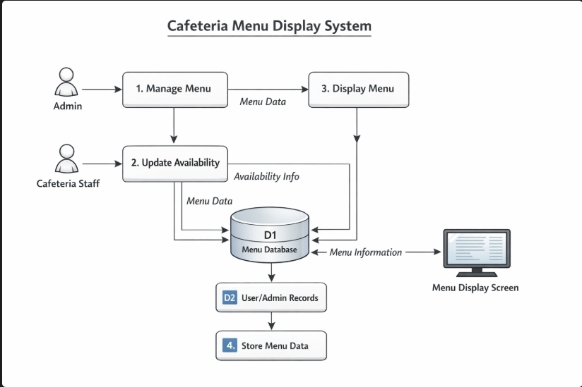

3.4 Technology Stack

Frontend: HTML, CSS, JavaScript
Backend: Python with Flask / Node.js
Database: MySQL / Firebase
Tools: VS Code, XAMPP, Postman, Git

4 PROJECT DESIGN

4.1 Problem-Solution Fit
• Manual Gap: Traditional cafeterias rely on paper menus or whiteboards that require manual rewriting every day, making it impossible to instantly communicate sold-out items or price changes. Staff waste time printing and updating boards, while customers face confusion when items are unavailable.
• The Fit: This digital system eliminates manual work by allowing real-time updates through an admin panel, with changes instantly reflected on the customer display. It bridges the communication gap between staff and customers, ensuring accurate information, reducing waste, and saving valuable staff time.

4.2 Proposed Solution
• Master Registry: Centralized database storing all menu items, categories, prices, images, and dietary tags with unique IDs for easy management and retrieval
• Workflow: Admin logs in → Updates menu items via forms → Backend processes changes → Database updates → Display auto-refreshes → Customer views real-time updated menu
• Automation: Auto-refresh every 5 minutes to fetch latest data, automatic image optimization on upload, and session timeout for admin security
4.3 Solution Architecture
• Relational Model: MySQL database with tables for Users (admin credentials), Categories (breakfast, lunch, etc.), and Menu Items (item name, price, description, category_id, image_url, is_available, is_special, dietary_tags) linked through foreign keys
• Scripting Layer: Python/Flask backend handling API endpoints for GET/POST requests, database queries, image upload processing, and admin authentication with session management

5 PROJECT PLANNING & SCHEDULING

5.1 Project Planning
• Weeks 1-2: Requirements gathering, database design, and setup of development environment with basic folder structure
• Weeks 3-4: Backend development including API endpoints, admin authentication, and database integration; frontend design for customer display
• Week 5: Testing, bug fixes, deployment, and final documentation preparation
6 FUNCTIONAL & PERFORMANCE TESTING

6.1 Performance Testing
• Efficiency: System loads menu within 3 seconds and auto-refreshes every 5 minutes without lag under normal cafeteria traffic
• Accuracy: Menu data displayed matches exactly with database entries, with zero discrepancy between admin updates and customer view
• Security: Admin panel protected by password authentication with session timeout; all user inputs validated to prevent SQL injection and unauthorized access
7 RESULTS

7.1 Output Screenshots

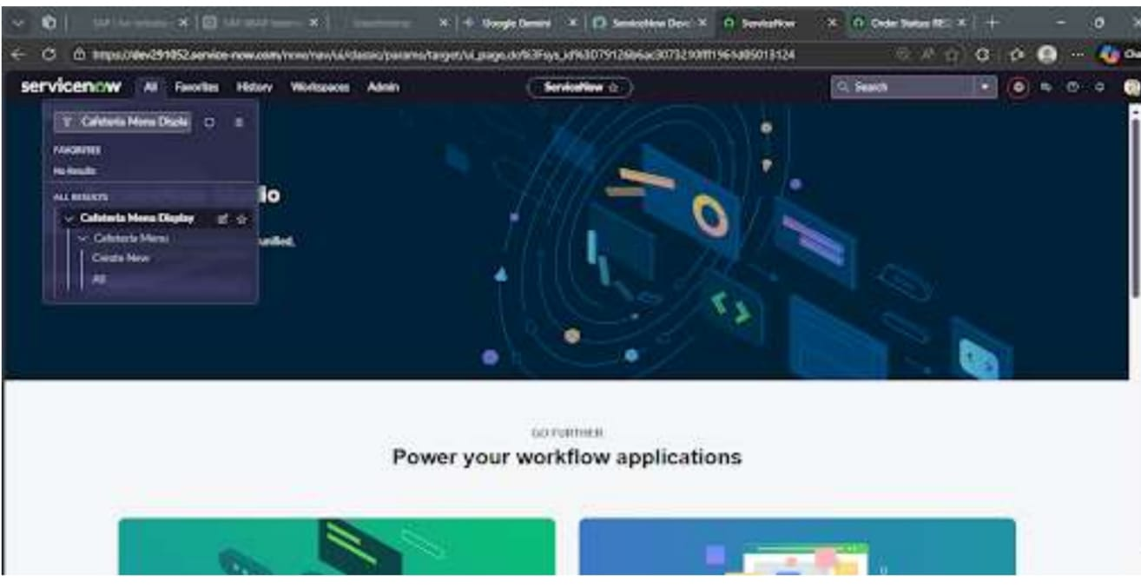

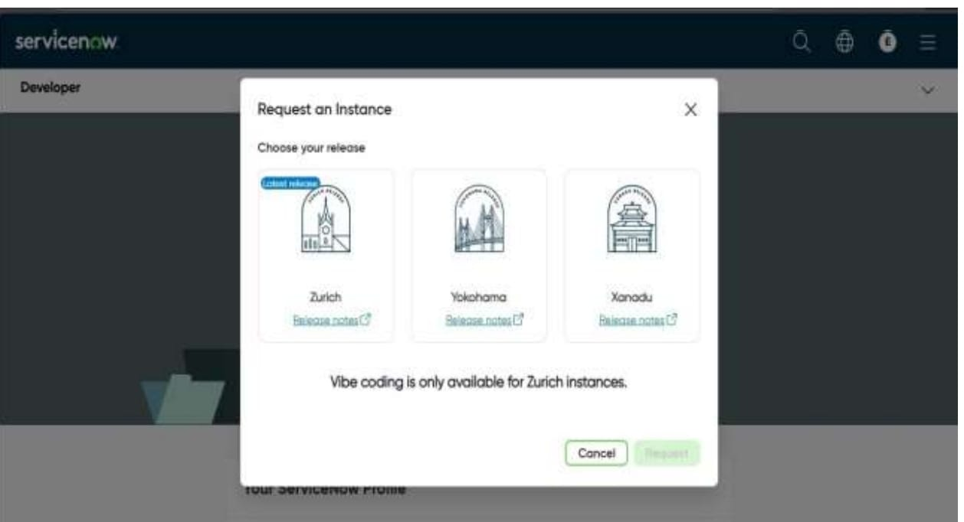
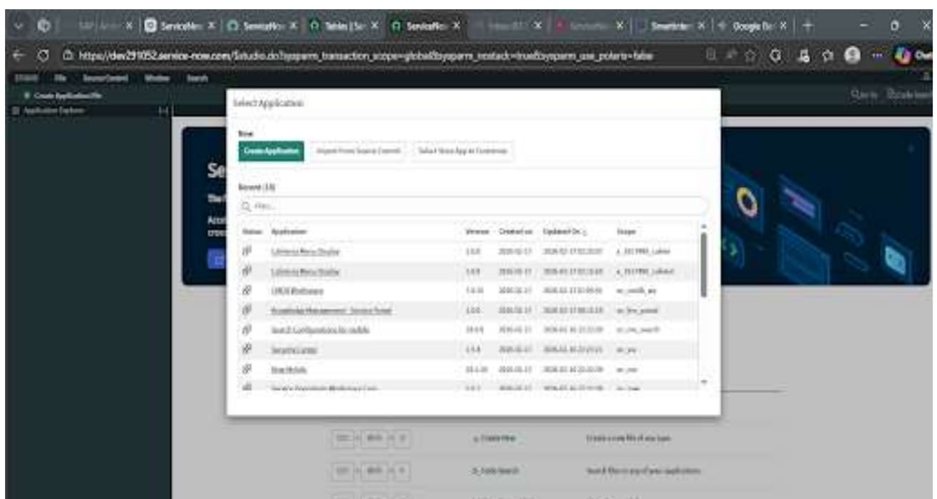

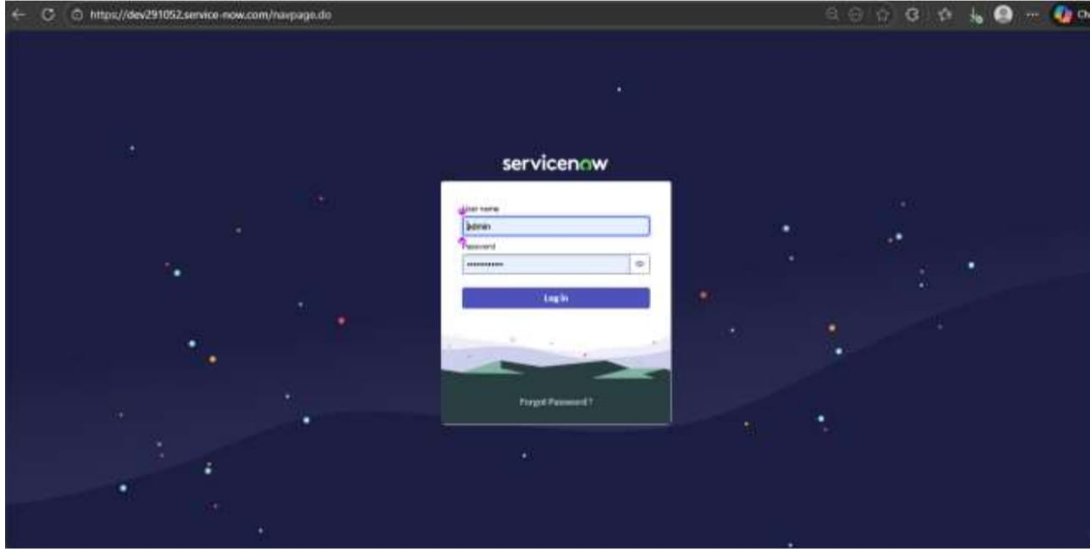

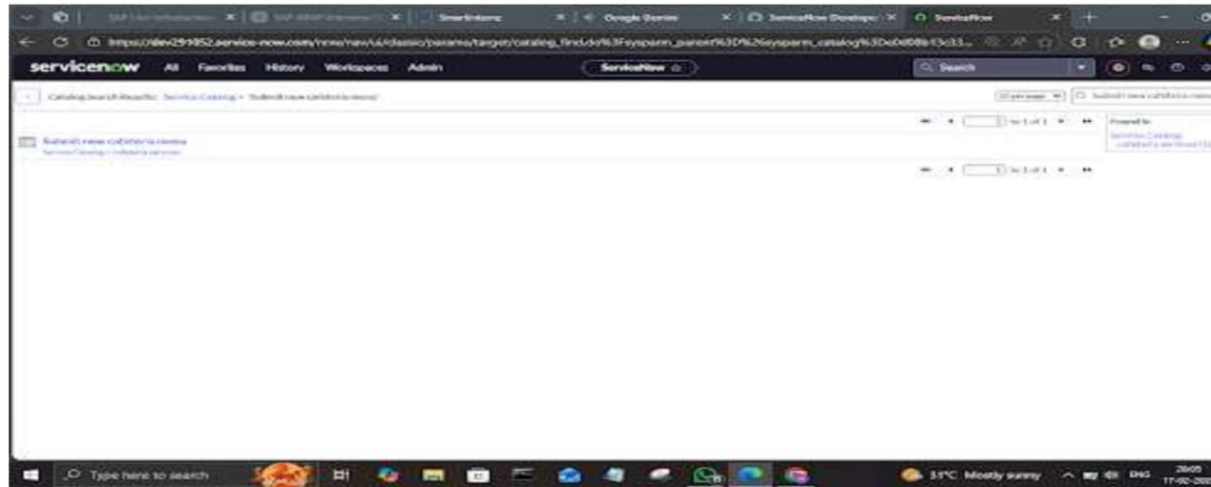

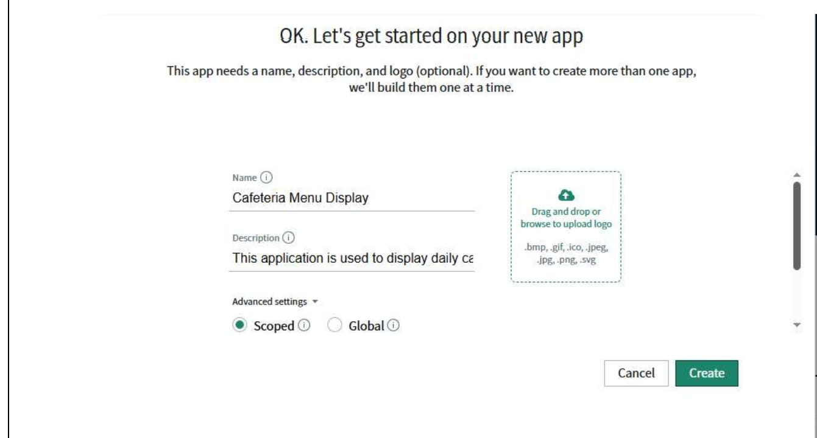

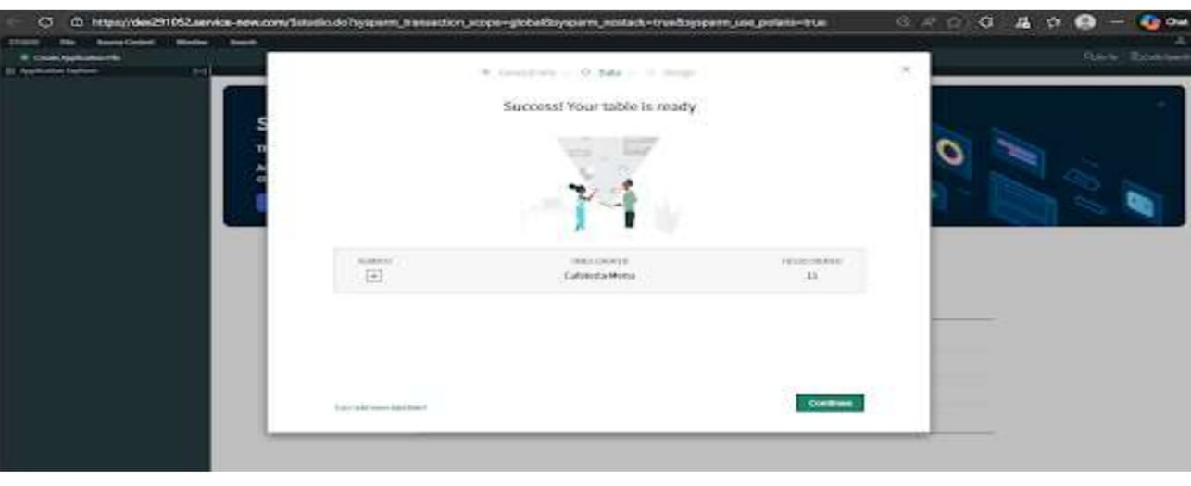

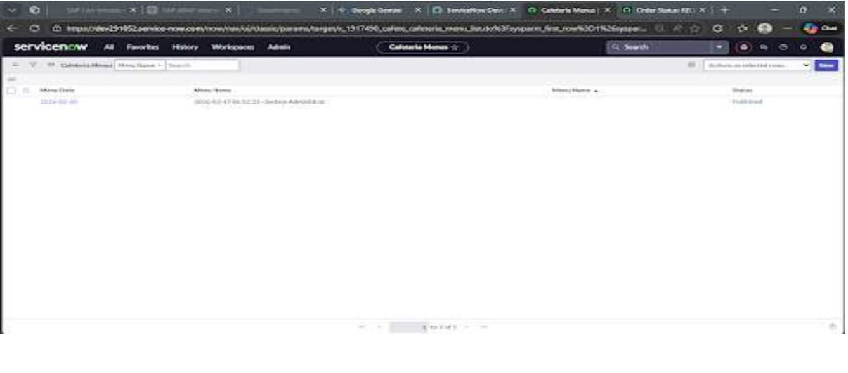

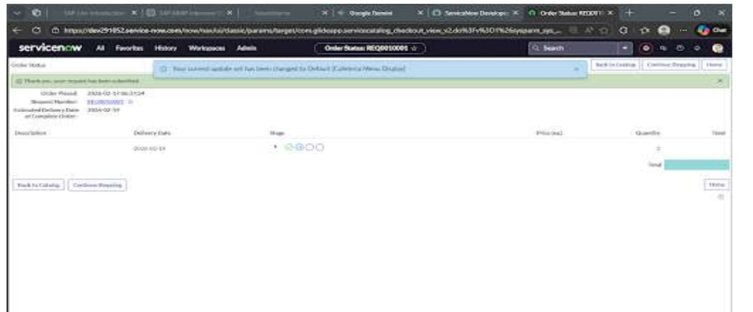

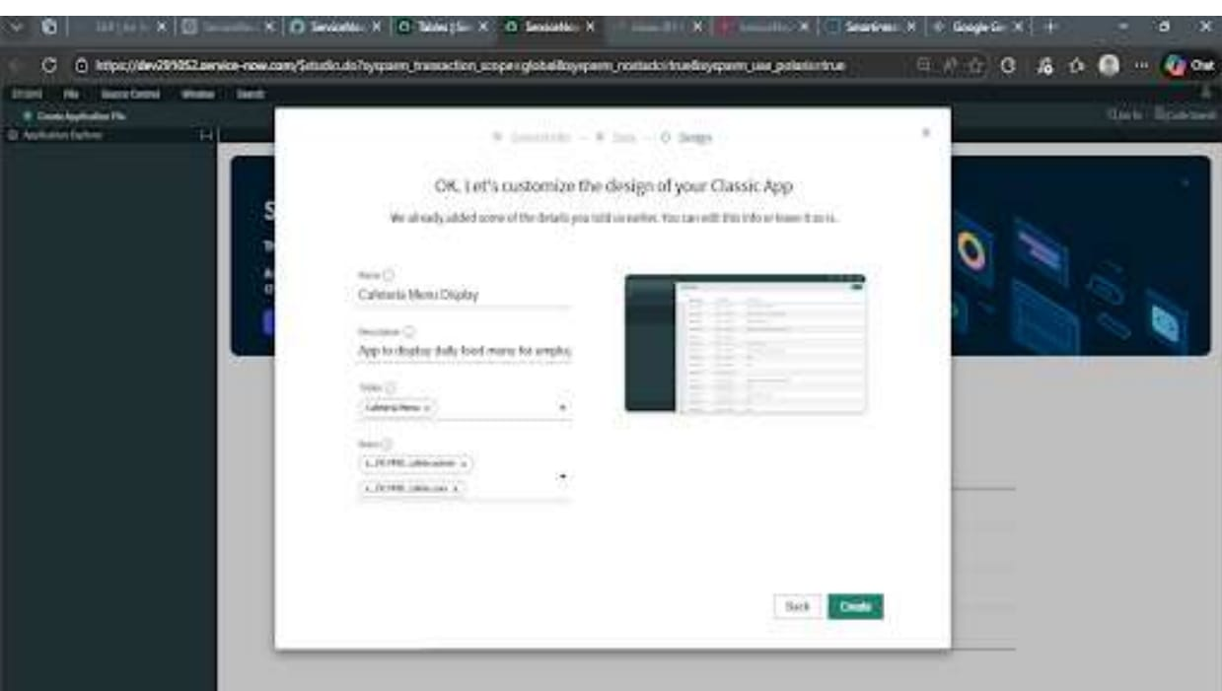

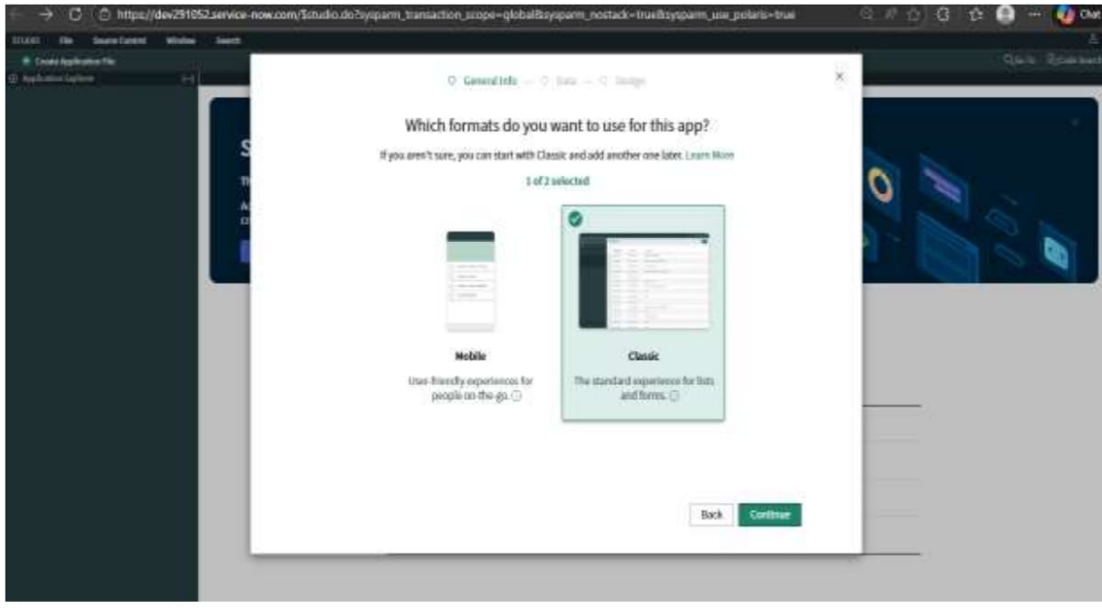

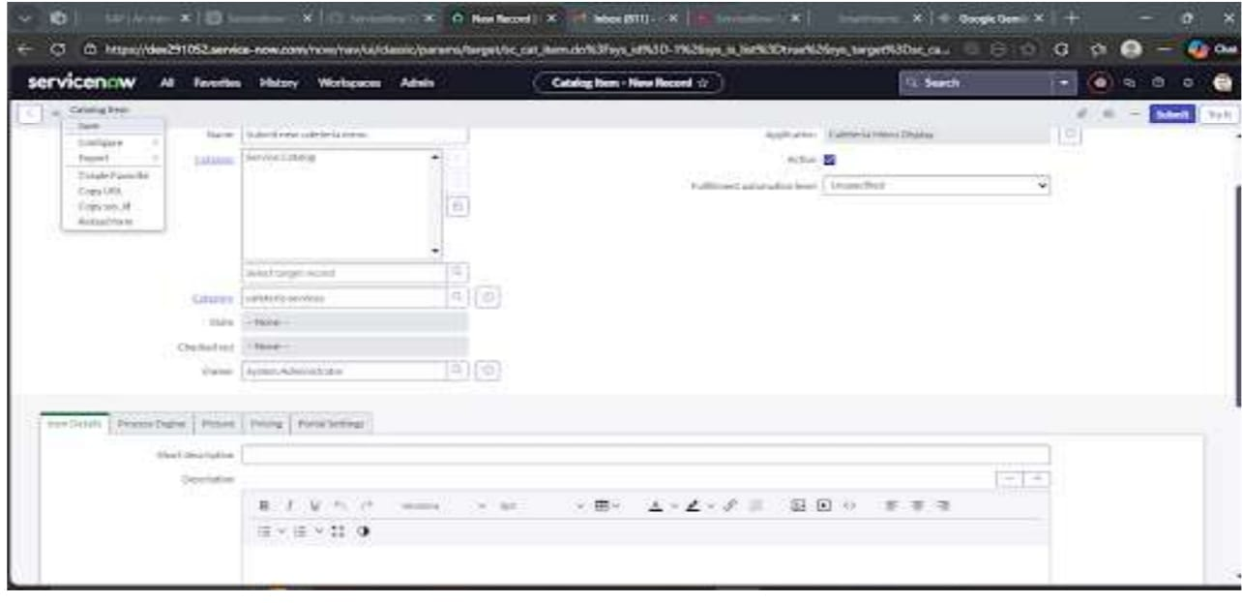

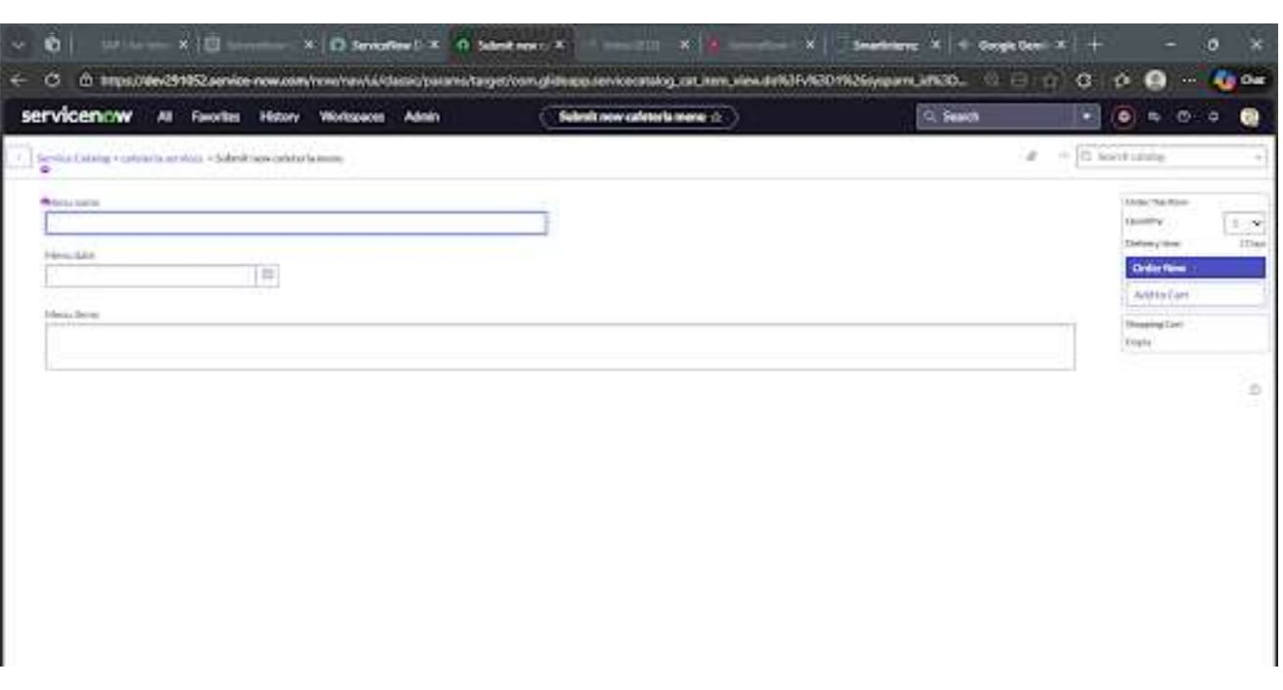

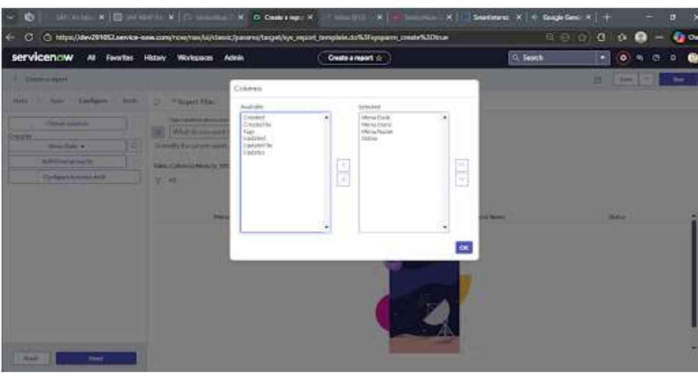

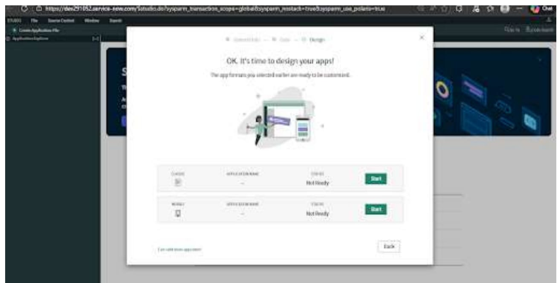

8 Advantages and Disadvantages
• Advantages: The system eliminates paper waste and printing costs while saving staff time through instant digital updates. It provides customers with clear, accurate menu information including prices and dietary icons, enhancing their overall dining experience.
• Disadvantages: The system requires initial investment in hardware like screens and depends on stable internet connectivity and power supply to function properly. Staff need basic technical training to use the admin panel effectively.

- CONCLUSION
The Cafeteria Menu Display System successfully addresses the limitations of traditional paper menus by providing a dynamic, real-time digital solution that benefits both staff and customers. With its intuitive admin panel, visually appealing customer display, and robust backend, the project streamlines cafeteria operations, reduces costs, and enhances the overall dining experience. This system demonstrates how technology can transform everyday processes, and its modular design allows for future enhancements like mobile ordering and nutritional information, ensuring long-term value and adaptability.

- FUTURE SCOPE

The system can be expanded with a mobile app allowing customers to view menus and place orders remotely. Nutritional information and calorie counts can be added to help health-conscious diners. Integration with digital signage can display video ads alongside menus. Multi-language support can cater to diverse customer bases, while AI-powered analytics can track popular items to help staff make data-driven decisions

11 APPENDIX

- Sample Data

Default Admin: Username - admin, Password - admin123
Sample Categories: Breakfast, Lunch, Beverages, Desserts
Sample Menu Items: Idli ($2.50), Biryani ($8.99), Coffee ($2.00)

- Hardware Requirements

Display Screen: Minimum 32-inch LED TV or Monitor
Server: Computer/Raspberry Pi with 4GB RAM
Network: WiFi or Ethernet connection

- Software Versions

Python 3.8+
MySQL 5.7+
Flask 2.0+
HTML5/CSS3 compatible browser

- API Endpoints Summary
GET /api/menu - Fetch all menu items
POST /api/admin/login - Admin authentication
POST /api/admin/add - Add new menu item
POST /api/admin/update/{id} - Update existing item
DELETE /api/admin/delete/{id} - Remove menu item

E. Folder Structure Reference
cafeteria-menu-display/
├── backend/
├── frontend/
├── database/
├── .env
└── README.md

- GitHub Link

